Elmwood Kitchen: Gourmet meals on wheels for seniors

By Pam Shearer
Correspondent

Perhaps you’ve heard of Meals on Wheels, a service which provides meals for seniors who can’t get out. Now there’s a “new meal” in town, Elmwood Kitchen. Owner and Chef Zhanna Brel describes Elmwood Kitchen as “like gourmet meals on wheels.”
Brel worked at adult daycare in Hartford and got to know what seniors liked to eat. She saw the need and the opportunity to provide traditional American cuisine for seniors.
“It’s high quality, fresh meals that taste very good,” adds Patrice Freeman, Elmwood Kitchen’s manager. “We’ve really emphasized taste so that seniors will have the fresh meals that they can eat so that they can enjoy it; they are also very nutritional meals.”
A consultant dietician plans the menu, which as 28 monthly entrees. The choices read like restaurant fare: baked teriyaki salmon, lasagna with spinach and mozzarella cheese, New York style stuffed cabbage, veal roulade with gravy, grilled German knockwurst, chicken blintzes, and Swedish meatballs.
The formula appears to be working. In six plus months of business, close to 50 seniors have signed up for Elmwood Kitchen meals. One of those satisfied customers is 88-year-old Mary McCaffrey, a longtime West Hartford resident.
“I got tired of trying to cook my own meals all the time,” she explained. “It’s very hard when you’re cooking for one person.”
McCaffrey started ordering from Elmwood Kitchen just before Thanksgiving with a salmon dinner, perfect for a lady who loves fish. She’s found delivery reliable and meal choices flexible. McCaffrey, who gets the meals twice a week and has no dietary restrictions, describes the service as “good home cooking” and praises the mashed potatoes as “nice and fluffy.” She believes the Elmwood Kitchen meals are a good choice for anyone that lives alone or for handicapped individuals.
“They’re good, they’re nutritious,” she said. “There’s the variety. What more can I say?”
The children of Elmwood Kitchen clients are just as pleased. West Hartford resident Louise White belongs to the sandwich generation, caring for her own children while also looking after her own mother, Eugenie White, 77, a Wethersfield resident. After her mom’s two minor strokes, Elmwood Kitchen was just what Louise White was looking for to provide for her mom. Since September, Eugenie White has gotten meals three days a week.
“It’s just such a relief for me,” Louise White said. “I was concerned with her eating habits. Was she eating TV dinners, too many fast food things, food of convenience?”
She appreciates the quality and the flexibility of Elmwood Kitchen, especially on meal choice. When knockwurst was on the menu, her mom, not a knockwurst fan, opted for another entrée. Louise White also likes the concern the staff shows.
“It’s not just even the business end of it,” she said. “They’re really nice to my mom; they don’t rush her through it.” She hopes more seniors will realize Elmwood Kitchen is available.
A West Hartford native with parents still in town, Freeman briengs experience as a hospital administrator in Rhode Island and Connecticut to her job. She speards the word of Elmwood Kitchen at senior events, hospital meeting with discharge planners, and visits to convalescent homes.
She presents Elmwood Kitchen as a good choice for those recuperati8ng from surgery or illness or just trying to stay healthy. She’s the voice on the phone, spending time getting to know the seniors, their diet restrictions, and their situations. She loves talking to them and laughs as she recalls one conversation with an 80-year-old who yearned for lasagna with the sauce and sausage like his mother made. Freeman is also out in the community talking to adult children who sometimes bring meals to their parents to make sure they eat right.
“They’re worried about them,” she said. “They are very relieved when the parents begin, even if for some of them it’s only a few days a week.”
With 24 hours notice, Elmwood Kitchen can get meals to seniors. Prices are affordable too, just $9 a day for two meals with one meal a dy $6.75. (Financial help may be available from Connecticut Home Care Program for Elders.)
Every season has a different menu with fresh ingredients. A day’s meal consists of lunch and dinner with beverages, fresh fruit, and desserts. Meals come in a sturdy grocery sack with labeled diet restrictions like diabetic, kosher, low-salt, or low-fat. They arrive fresh but can be frozen and all are microwave or oven ready.
Usually, one meal is more than enough, although one client ordered two. Whatever is on the menu will satisfy taste buds at any age. One of the popular choices, meat loaf, brings back memories of mom’s cooking. Not too spicy, it has thick gravy, perfect for the mashed potatoes that come with the meal. Freeman said other favorites are egg salad sandwiches and the traditional Thanksgiving turkey dinner. Elmwood Kitchen works with seniors to make their own meals schedules, seven days a week or just one.
“We take the time,” said Freeman. “We are not one size fits all.”
The Elmwood Kitchen staff of six makes sure the meals arrive, no matter what the weather. The Dec. 9 snowstorm that closed most schools in Connecticut didn’t close Elmwood Kitchen; they made their usual deliveries on routes that have gone beyond West Hartford. The arrival of the meals is always welcome.
“It provides them a break from shopping and cooking, especially even in the winter months; this is a wonderful service for seniors,” said Freeman. “They deserve a break at this point with the various health concerns; it’s hard for them sometimes to cook; it’s a major stress reliever for them.”

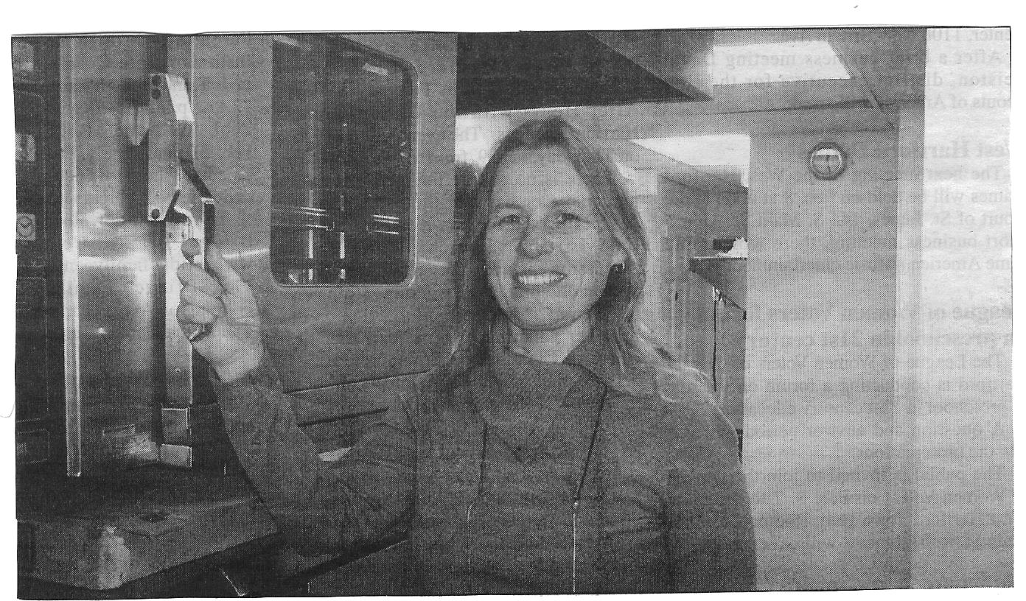
Patrice Freeman manages the “new meal” in town, Elmwood Kitchen, which provides meals for seniors who can’t get out.

